***Most IMP 🡪 Chapter 02***

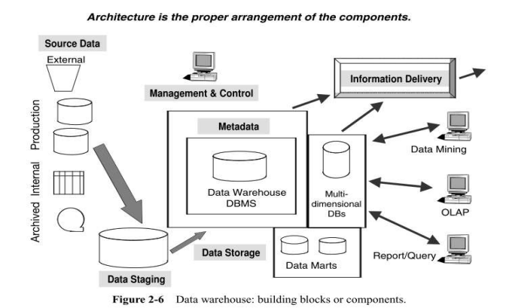

***Answer: Interpretation and Function of Each Component in the Data Warehouse Architecture***

***1. Source Data Component***

*Includes production data, internal data, archived data, and external data.*

* ***Production Data:*** *Extracted from operational systems with diverse formats, hardware platforms, and database structures. It is standardized, transformed, and integrated for the warehouse.*
* ***Internal Data:*** *Private files such as spreadsheets and customer profiles, marketing budgets, and profit and loss statements adding complexity due to their unstructured nature. Based on collective judgment, you will decide how much internal data is to be included in a data warehouse*
* ***Archived Data:***  *OLTP systems periodically transfer “old data” and store it in archived files. Many archiving methods exist. Historical data from OLTP systems, used for trend analysis and patterns.*
* ***External Data:*** *Most executives depend on data from external sources. This data comes from the market, including customers and competitors.*

*Like:*

* *Statistics produced by external agencies.*
* *Market share data of competitors.*
* *Standard values of financial indicators etc.*

*Data from outside does not conform to your formats.*

*Organize data transmission Conversion into internal data formats and types.*

***2. Data Staging Component***

*Responsible for data extraction, transformation, and loading (ETL).*

* + ***Extraction:*** *Pulls data from various sources, which may vary in format, structure, and platform. Tools or inhouse programs are used to handle the complexity of this process. The extracted data is stored in a separate environment for further preparation.*
  + ***Transformation****: Cleans extracted data by correcting errors, resolving conflicts like synonyms and homonyms, and eliminating duplicates. It standardizes data formats and integrates information from multiple sources. The process also includes removing/purging irrelevant data, summarizing, and assigning surrogate keys.*
  + ***Loading****: Initial loading involves moving large datasets into the warehouse when the system is implemented, requiring significant time. Incremental updates extract and load new or revised data regularly, keeping the warehouse current and accurate.*

***3. Data Storage Component***

*A dedicated repository for stable, summarized, and large volume data, distinct from operational databases.*

*Utilizes multidimensional database management systems (MDDBs) for storing integrated and nondynamic data.*

***4. Information Delivery Component***

*Provides data access and insights to different user groups such as business analysts and novice users.*

*Enables various methods like OLAP, data mining, and reports/queries for knowledge discovery and decision making.*

***5. Metadata Component***

*Metadata is "data about data", providing meaning and context.*

*Types:*

* ***Operational Metadata****: Details of source systems.*
* ***Transformation Metadata:*** *Rules for extraction and transformation.*
* ***Enduser Metadata:*** *A navigational map for the data warehouse.*

*Functions as the "glue" connecting all parts of the warehouse and ensures data consistency.*

***6. Management & Control Component***

*Oversees and coordinates all data warehouse activities, including data extraction, transformation, storage, and delivery.*

*Ensures seamless operation and synchronization among components.*

*By organizing these components as shown in the figure, the architecture facilitates data integration, analysis, and efficient decision making.*

***Data Granularity in a Data Warehouse***

***1. Definition of Data Granularity***

*Data granularity refers to the level of detail or summarization of data stored in the data warehouse.*

***Low granularity:*** *Highly detailed data (e.g., individual transactions or seconds).*

***High granularity:*** *Summarized data with less detail (e.g., monthly totals or regional summaries).*

*Proper granularity ensures efficiency in storing, querying, and analyzing data.*

***2. Importance of Granularity in Data Warehousing***

*Determining the right granularity is crucial for smooth design and implementation.*

*High granularity enables quick highlevel analysis but lacks specific details.*

*Low granularity allows for detailed insights but increases storage and processing requirements.*

*The right balance facilitates effective analysis while optimizing storage.*

***3. Granularity in Operational Systems vs. Data Warehouses***

*Operational systems store data at the lowest level of detail (e.g., product units sold per transaction).*

*Data warehouses often store data at multiple granularity levels to support different user needs:*

*Summary data for initial highlevel analysis (e.g., regional sales totals).*

*Detailed data for deeper insights (e.g., state or store level sales).*

***4. Example Use Case***

*In a grocery store operational system:*

*Data captured: Product units sold per transaction at the checkout.*

*To get monthly sales, individual transactions are aggregated.*

*In the data warehouse:*

*Summarized data (e.g., total sales by region or state) is stored for quick access.*

*Detailed data (e.g., individual store transactions) is available for drilldown analysis.*

***5. Granularity Levels and Analysis***

*Users typically start their analysis with summary data (e.g., total sales in a region).*

*They drill down to more granular levels for deeper insights (e.g., state or store level sales).*

*Efficient granularity supports this multilevel analysis, optimizing performance and usability.*

*Exercise: Identifying Granularity Needs for an Organization*

***Organization Example****:*

*A national retail chain is facing challenges with their operational databases and requires a data warehouse solution.*

***Issues with Operational Databases:***

*1. Performance bottlenecks when running complex queries on transactional systems.*

*2. Lack of historical data for trend analysis.*

*3. Inability to aggregate data efficiently for regional or corporate decisionmaking.*

*4. Poor support for ad hoc queries and multidimensional analysis.*

***How a Data Warehouse Helps:***

***1. Multilevel granularity:***

*Highlevel summaries: Monthly sales by region or product category.*

*Intermediate summaries: State and store level sales totals.*

*Detailed data: Individual transactions for specific analysis.*

***2. Data aggregation:*** *Pre aggregated data improves query performance for highlevel insights.*

***3. Historical storage:*** *Allows year over year and seasonal trend analysis.*

***4. Enhanced reporting:*** *Supports drilldown and slice and dice analysis for decision making.*

***Required Levels of Granularity:***

***Highlevel granularity:*** *Monthly sales by product category for regional managers.*

***Midlevel granularity:*** *Weekly sales by store for operational managers.*

***Lowlevel granularity:*** *Daily or transactional data for individual product level analysis (e.g., promotions).*

*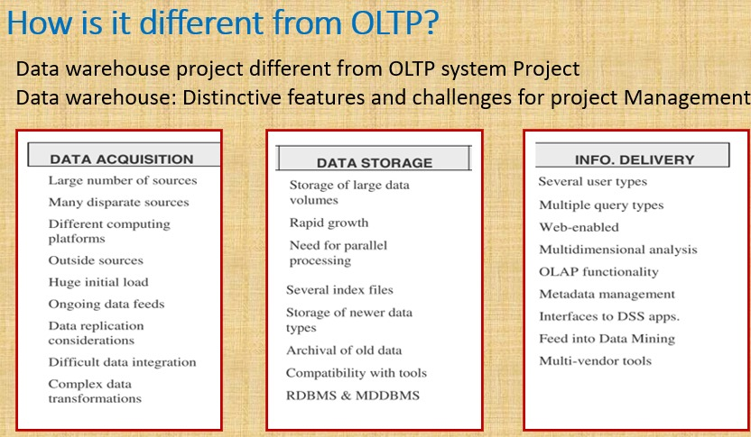s*

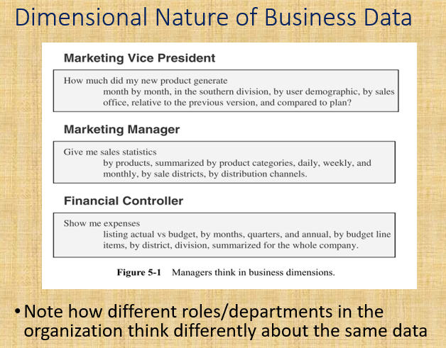

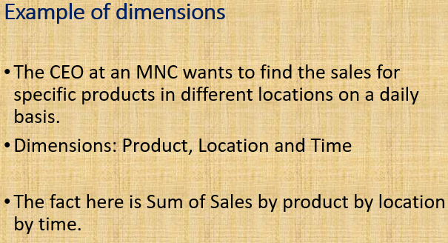

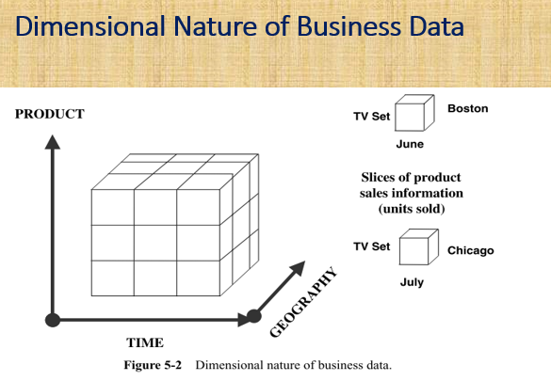

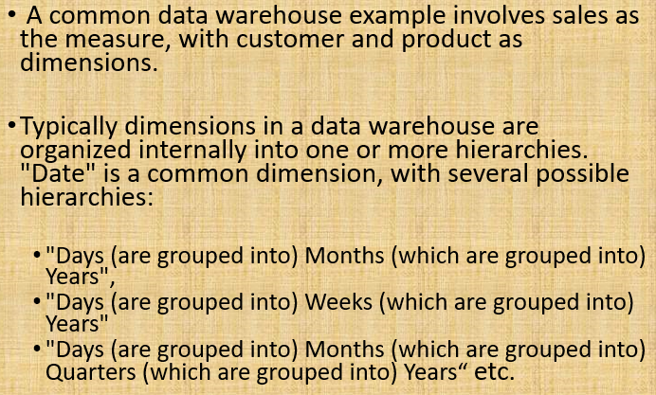

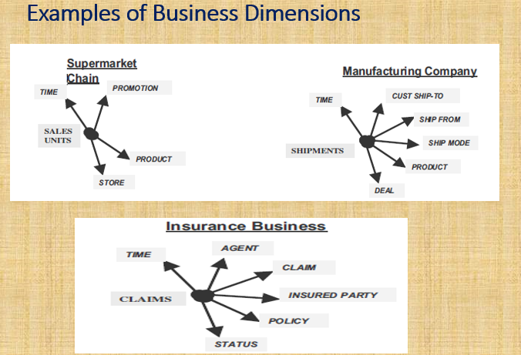

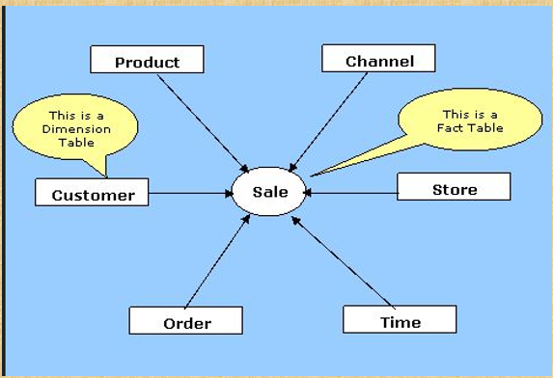

**

***Three Ways to Analyze Sales:***

***1. By Product:*** *Analyze sales performance for each product type or category to identify bestsellers and underperformers.*

***Dimensions:*** *Product, Time, Location.*

***2. By Region:*** *Compare sales across geographic locations to understand regional demand variations.*

***Dimensions:*** *Location, Time, Dealer.*

***3. By Customer Demographics:*** *Study customer profiles (age, income, etc.) to tailor marketing strategies.*

***Dimensions:*** *Customer Demographics, Time, Product.*

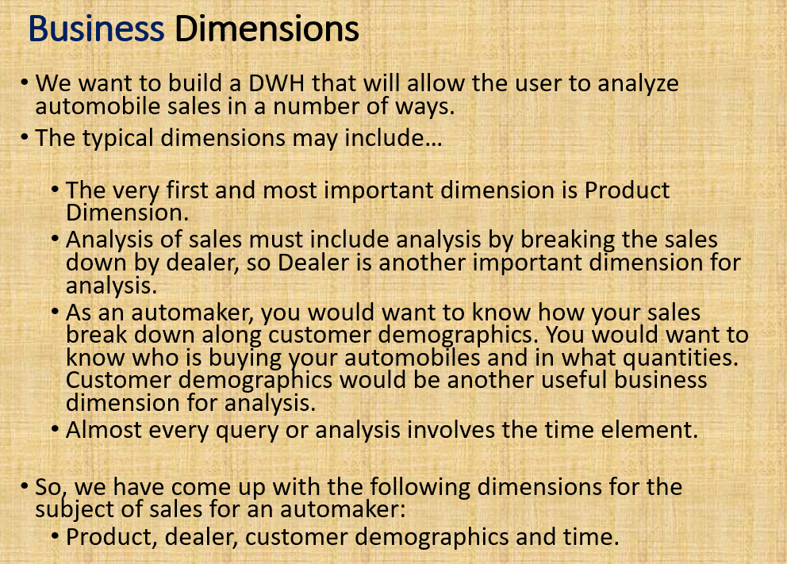

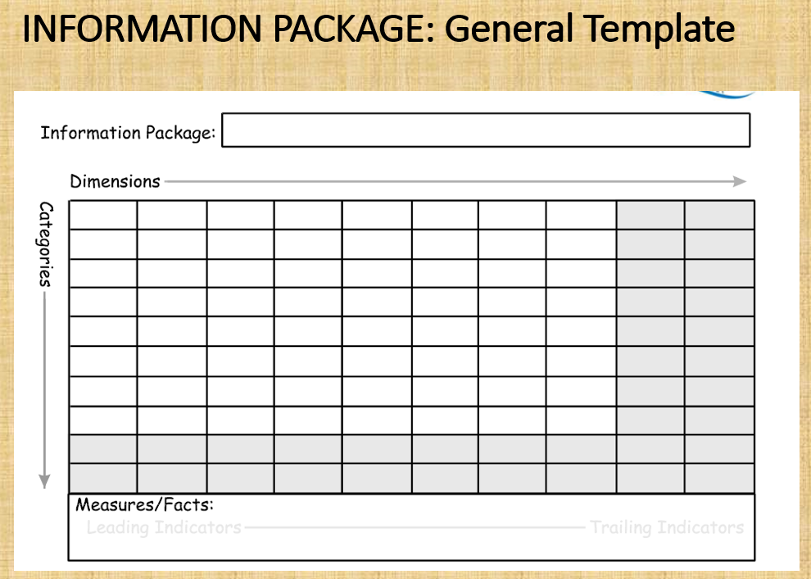

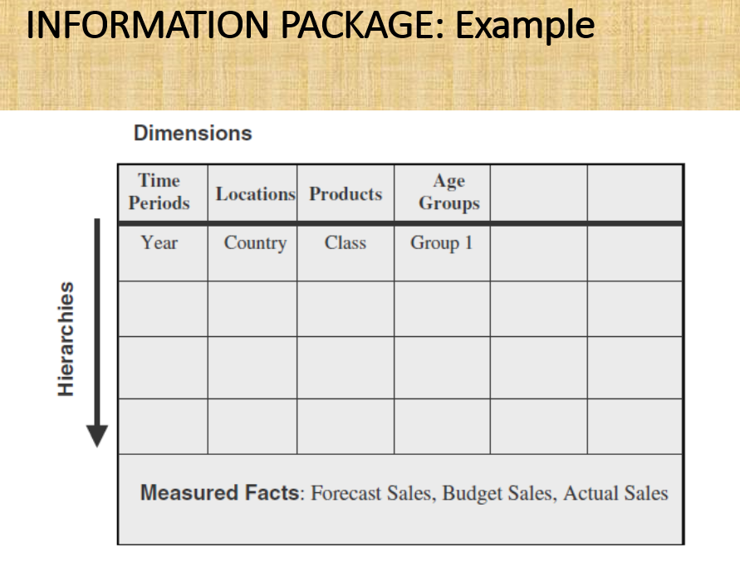

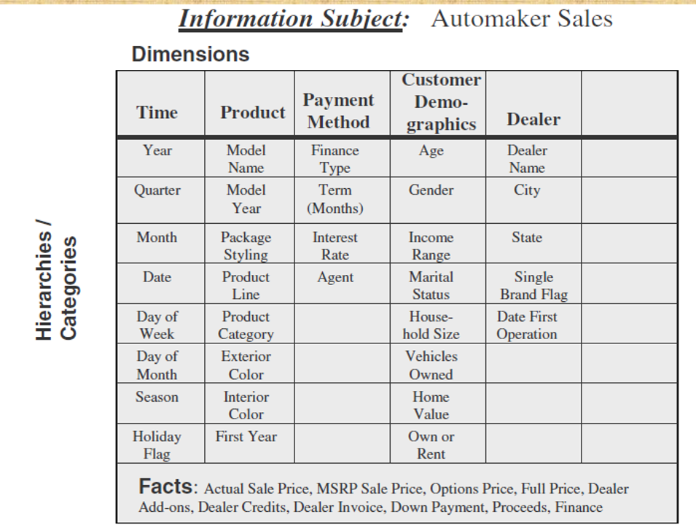

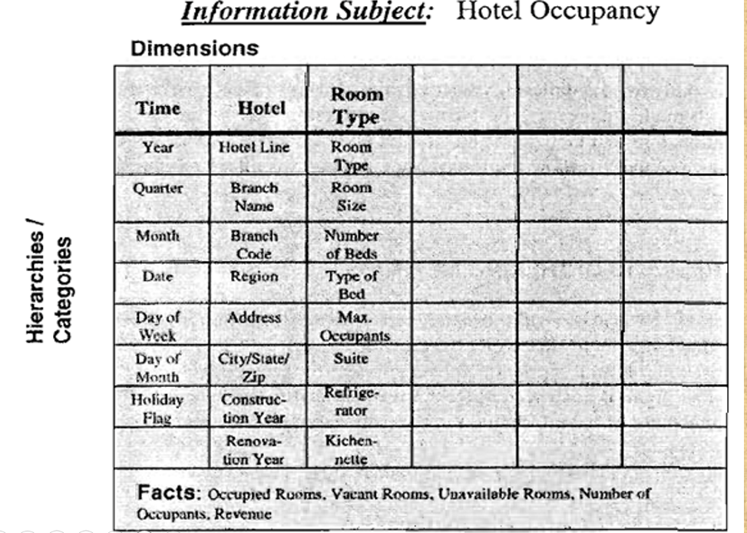

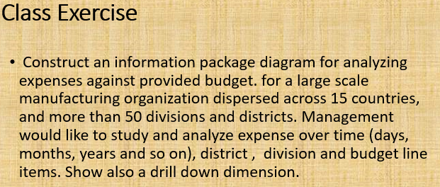

*Information Package Diagram: Analyzing Expenses Against Budget*

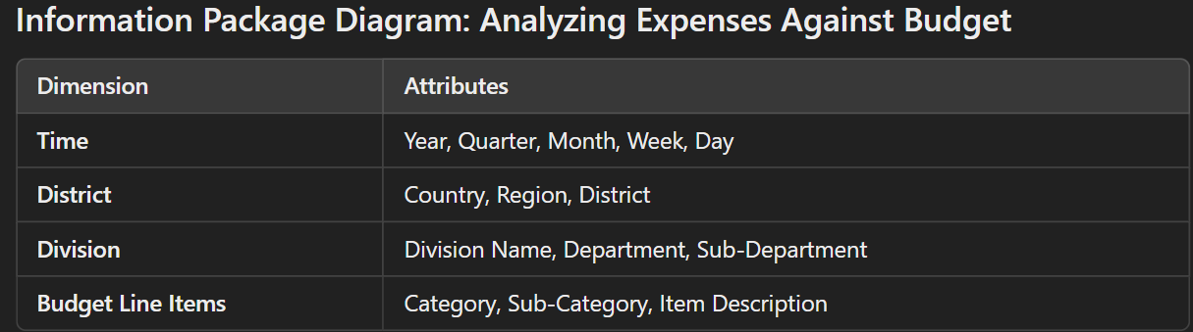

*Facts (Metrics):*

*Total Expenses*

*Budget Allocated*

*Variance (Expense vs. Budget)*

*Percentage of Budget Utilized*

*DrillDown Dimensions:*

*1. Time Hierarchy: Year → Quarter → Month → Week → Day*

*2. Geographic Hierarchy: Country → Region → District*

*3. Organizational Hierarchy: Division → Department → SubDepartment*

*This diagram enables management to evaluate expense performance at multiple granularities, such as by time periods, organizational structure, or specific budget items.*

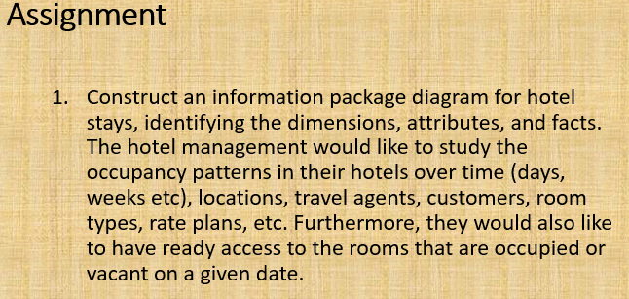

***Information Package Diagram: Hotel Stays Analysis***

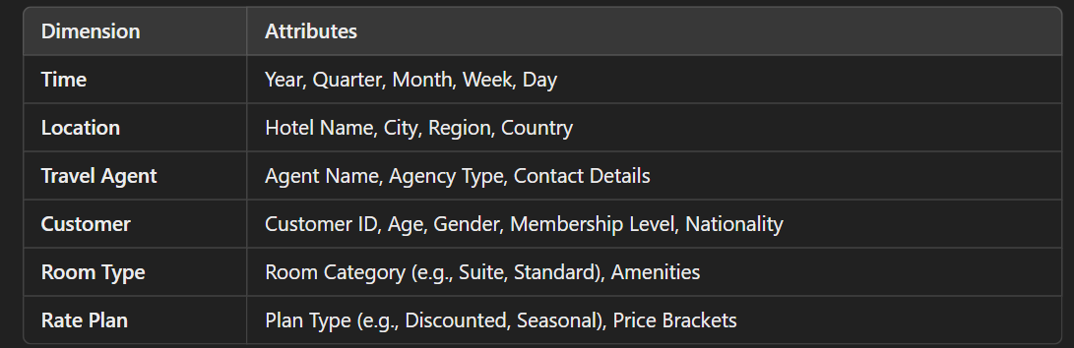

***Facts (Metrics):***

*Total Stays*

*Room Nights (number of nights rooms are occupied)*

*Occupancy Rate*

*Revenue Per Available Room (RevPAR)*

*Average Daily Rate (ADR)*

*Rooms Vacant*

***DrillDown Dimensions:***

*1. Time Hierarchy: Year → Quarter → Month → Week → Day*

*2. Location Hierarchy: Country → Region → City → Hotel Name*

*3. Room Type Hierarchy: Category → Subcategory → Amenities*

*This diagram helps in analyzing occupancy patterns, revenue trends, and operational performance, and ensures data for decisions like marketing strategies, pricing adjustments, and capacity planning is readily accessible.*

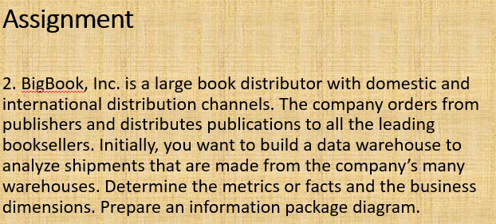

***Information Package Diagram: Shipments Analysis for BigBook, Inc.***

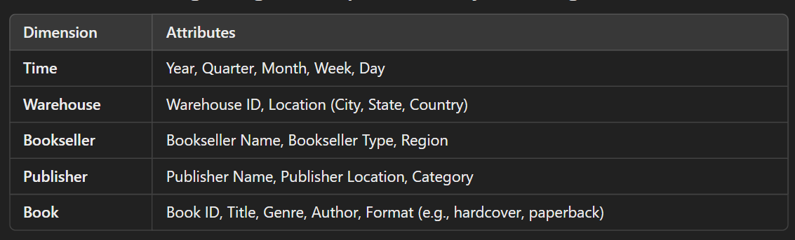

***Facts (Metrics):***

*Total Shipments*

*Shipment Volume (number of units)*

*Shipment Weight*

*Delivery Time (actual vs. scheduled)*

*Cost of Shipment*

*Revenue Per Shipment*

***DrillDown Dimensions:***

*1. Time Hierarchy: Year → Quarter → Month → Week → Day*

*2. Geographic Hierarchy: Country → State → City → Warehouse Location*

*3. Book Hierarchy: Genre → Author → Book Title*

*This diagram provides insights into shipment patterns, efficiency, and profitability, helping optimize operations, assess vendor performance, and improve service levels.*

***CHAP 04***

***REQUIREMENTS GATHERING METHODS***

***Importance of Requirements Gathering***

*When 38 IT professionals in the UK were asked about project failures, most pointed to the “requirements definition” phase. Requirements are the foundation for building a system and specify what the system should do or how it should perform.*

***Goal:*** *The objective is to make requirements specific, unambiguous, and clear, reducing the chances of miscommunication or misinterpretation.*

***Users and Sources for Requirements Gathering***

***Who are the users?***

*The users of a data warehouse typically fall into the following categories:*

***1. Senior Executives:*** *Project sponsors or highlevel decision makers.*

***2. Key Departmental Managers:*** *Managers who represent critical business functions.*

***3. Business Analysts:*** *Individuals who interpret and analyze the data.*

***4. Operational System DBAs:*** *Database administrators of operational systems who provide technical expertise.*

***5. Others:*** *Any additional users nominated by the above groups.*

***Where do you gather requirements?***

*The data sources for requirements gathering include:*

*Operational systems that generate key data for business subject areas.*

*Existing reports and queries currently used for business decision making.*

*Feedback from key stakeholders about the desired improvements and unmet needs.*

***Types of Requirements to Gather***

***1. Data Elements:***

*Identify facts, classes, and dimensions of data needed for analysis.*

*Ensure the hierarchical structure of the dimensions is captured.*

***2. Timebased Records:***

*Understand how data is recorded over time (e.g., daily, monthly, yearly).*

*This helps in determining granularity for analysis.*

***3. Source System Data Extracts:***

*Define the flow of data from operational systems to the data warehouse.*

*Capture any operational rules needed for extracting or cleaning this data.*

***4. Business Rules:***

*Document the attributes, domains, and operational data required for analytical purposes.*

***Requirements Gathering Techniques***

***1. Interviews***

*Interviews are conducted either oneonone or with small groups.*

*Advantages:*

*Best for gathering intricate details.*

*Provides an opportunity to explore issues deeply.*

*Allows for personalized interactions and clarifications.*

***Challenges:***

*Can be time consuming.*

*Visiting or meeting everyone may not always be feasible.*

***Steps to Conduct Effective Interviews:***

*Train the project team on interview techniques.*

*Assign specific roles (e.g., lead interviewer, notetaker).*

*Prepare a detailed list of users to interview.*

*Conduct pre interview research on the user’s business functions.*

*Share interview questionnaires in advance to help users prepare.*

*Start with a kickoff meeting to explain the process and set expectations.*

***2. JAD (Joint Application Development) Sessions***

*JAD sessions are structured meetings with groups of people.*

***Best Used For:*** *Confirming and finalizing requirements after initial interviews.*

*Group Size: Up to 20 participants at a time.*

***Advantages:***

*Facilitates collaboration and feedback.*

*Encourages alignment among stakeholders.*

***Challenges:***

*Requires thorough preparation and organization.*

*Not ideal for initial data gathering due to the complexity of group discussions.*

***PreInterview Research***

*Before conducting interviews, it’s essential to perform research on the business unit. This ensures that the team understands the context and can ask relevant questions.*

***Key areas of research:***

***1. Business Unit Relationships:*** *Understand how the unit interacts with other units and external organizations.*

***2. Revenue and Cost Contributions:*** *Learn about the unit’s financial impact on the company.*

***3. Market Position:*** *Research the company’s competitors and overall market trends.*

***4. Structure and Operations:*** *Gather details on the unit’s size, employees, locations, and responsibilities.*

***5. Strategic Role:*** *Identify how the unit aligns with the company’s objectives and strategic initiatives.*

***Sample Interview Questions***

*To ensure a comprehensive understanding of the requirements, here are some example questions:*

***1. Current Information Sources***

*What systems generate important business data?*

*What types of reports and queries are currently delivered?*

*What is the level of detail in the existing information?*

***2. Subject Areas***

*Which business subject areas are most valuable for analysis?*

*What are the natural hierarchies within the business dimensions?*

*Are there locationbased requirements (e.g., global vs. local decisionmaking)?*

***3. Key Performance Metrics***

*How is business performance currently measured?*

*What are the critical success factors (CSFs)?*

*How are key metrics aggregated (e.g., by product, region)?*

***4. Information Frequency***

*How often must data be updated for decisionmaking?*

*What timeframes are important for comparing metrics?*

***Documentation and Requirements Definition***

*Documenting the requirements properly ensures clarity and serves as a reference for the development team.*

*General Outline for Interview Writeups*

***1. User Profile:*** *Identify the person and their role in the organization.*

***2. Background & Objectives:*** *Highlight the user’s goals and challenges.*

***3. Information Requirements:*** *Capture what data they need and why.*

***4. Analytical Requirements:*** *Specify the types of analysis required.*

***5. Current Tools:*** *List tools they currently use.*

***6. Success Criteria:*** *Define what success looks like for the project.*

***7. Business Dimensions:*** *Identify relevant metrics and dimensions.*

***Scope and Content of Requirements Definition Document***

***1. Data Sources:*** *Document available sources, their location, and data formats.*

***2. Data Transformation:*** *Explain how data will be merged, converted, or split.*

***3. Data Storage:*** *Define storage needs, including data marts and aggregation.*

***4. Information Delivery:*** *Include requirements for drilldown, rollup, and ad hoc reports.*

***5. Information Packages:*** *Use package diagrams to detail metrics and dimensions.*

***Requirements Definition Document Outline***

***1. Introduction:*** *State the project’s purpose, scope, and justification.*

***2. General Requirements:*** *Summarize user interviews and source system reviews.*

***3. Specific Requirements:*** *Include detailed requirements for data, transformation, and storage.*

***4. Information Packages:*** *Provide package diagrams with detailed metrics and dimensions.*

***5. Other Requirements:*** *Cover additional needs, such as extraction frequencies.*

***6. User Expectations:*** *Highlight user expectations and how they plan to use the data warehouse.*

***7. User Participation & Signoff:*** *List tasks requiring user involvement and secure approval.*

***8. Implementation Plan:*** *Outline a highlevel plan for implementation.*

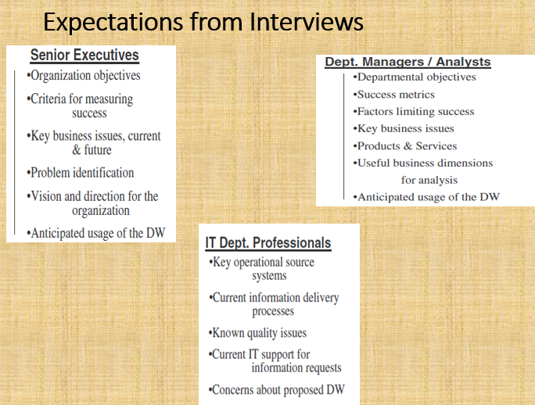

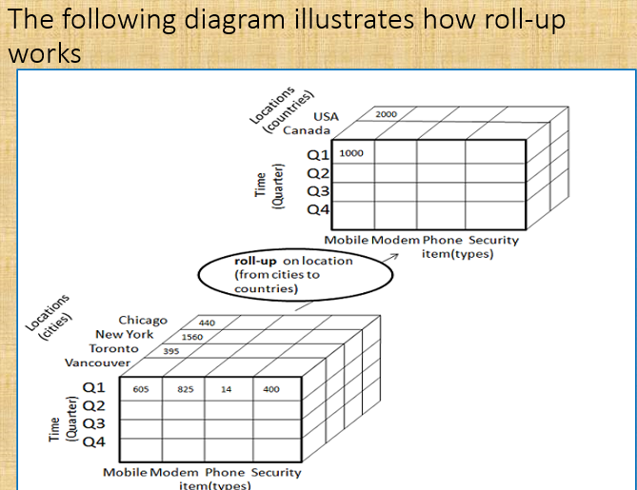

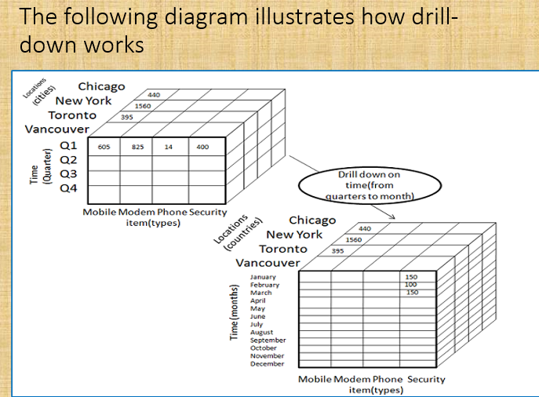

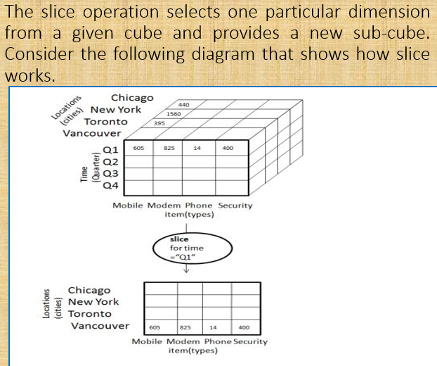

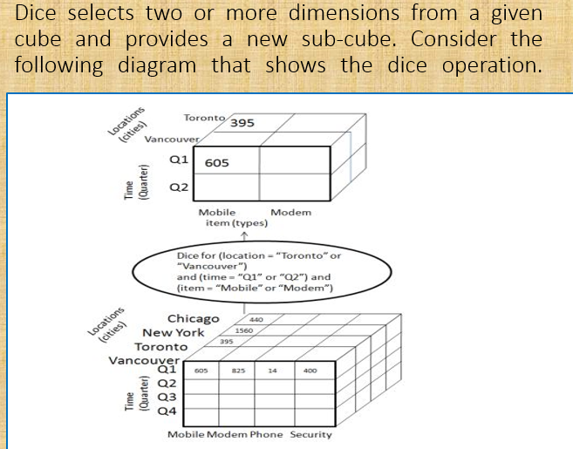

***CHAPTER 06***

***ETL vs. ELT***

*ETL (Extract, Transform, Load)*

*Traditional process for preparing data for storage in a data warehouse.*

*Process Steps:*

*1. Extract: Retrieve data from source systems (structured data).*

*2. Transform: Apply transformations like decoding, cleansing, and formatting.*

*3. Load: Store transformed data into the target data warehouse.*

*Advantages:*

*Ensures transformed, clean data in the warehouse.*

*Works well with large datasets in structured formats.*

*Offers reliable and consistent insights.*

*Disadvantages:*

*Timeintensive due to preloading transformations.*

*Requires more setup and predefined transformations.*

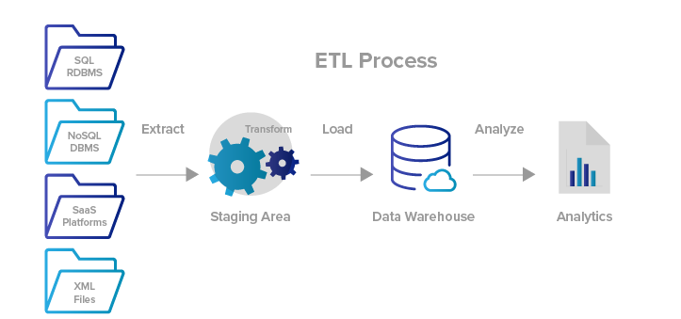

*ELT (Extract, Load, Transform)*

*Modern alternative enabled by cloudbased data lakes (e.g., Amazon Redshift, Google BigQuery).*

*Process Steps:*

*1. Extract: Pull data in its raw form from multiple sources.*

*2. Load: Store unprocessed data directly in a data lake.*

*3. Transform: Transform data postloading for specific needs.*

*Advantages:*

*More flexible and faster initial ingestion.*

*Transforms only the data needed for specific analyses.*

*Handles unstructured and semistructured data.*

*Disadvantages:*

*Less reliable for consistent and largescale transformations.*

*Tools are still evolving, leading to potential inefficiencies.*

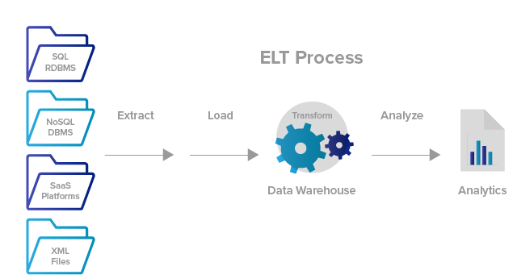

***Management of the ETL Process***

*Overview*

*ETL encompasses three phases:*

*Data Extraction: Identifying and extracting data from various source systems.*

*Data Transformation: Converting extracted data into formats suitable for analysis and storage.*

*Data Loading: Storing processed data into the data warehouse.*

*These processes form the backbone of data acquisition and storage in a data warehouse.*

*Data Extraction*

*1. Source Identification:*

*Identify applications and structures where data resides.*

*Analyze the compatibility of systems (e.g., different databases, platforms).*

*2. Extraction Strategy:*

*Manual vs. automated (using tools).*

*Consider the frequency of extraction (e.g., daily, weekly).*

*3. Extraction Techniques:*

*Static data extraction: Snapshot of data at a specific point (for initial loading).*

*Incremental data capture: Capturing changes over time (ongoing loads).*

*4. Challenges:*

*Data changes frequently (temporal data).*

*Requires strategies for error handling (e.g., incomplete records).*

*Data Transformation*

*Transformation ensures data is consistent, accurate, and usable for strategic decisionmaking.*

*Types of Transformations:*

*1. Format Revisions:*

*Standardize data types and lengths (e.g., converting numeric to text for product codes).*

*2. Decoding:*

*Replace cryptic codes with meaningful values (e.g., 1 → Male, 2 → Female).*

*3. Calculated and Derived Values:*

*Add fields like profit margin or age based on extracted data.*

*4. Splitting Fields:*

*Break fields like full name into first, middle, and last name for indexing.*

*5. Merging Information:*

*Combine related fields from different sources into one entity (e.g., product details from different systems).*

*6. Unit Conversion:*

*Convert measurements (e.g., metric to imperial units).*

*7. Summarization:*

*Store aggregated data (e.g., daily totals) instead of every transaction.*

*8. Key Restructuring:*

*Generate systembased keys to replace builtin meaningful keys.*

*9. Deduplication:*

*Identify and merge duplicate records into one.*

*Data Loading*

*The final stage involves applying transformed data to the data warehouse.*

*Modes of Loading:*

*1. Initial Load: Populate tables for the first time with all necessary data.*

*2. Incremental Load: Apply updates periodically to reflect ongoing changes.*

*3. Full Refresh: Erase and reload entire tables for complete updates.*

*Challenges:*

*Requires a downtime window to prevent disruptions.*

*Test loads are necessary to estimate runtime and validate correctness.*

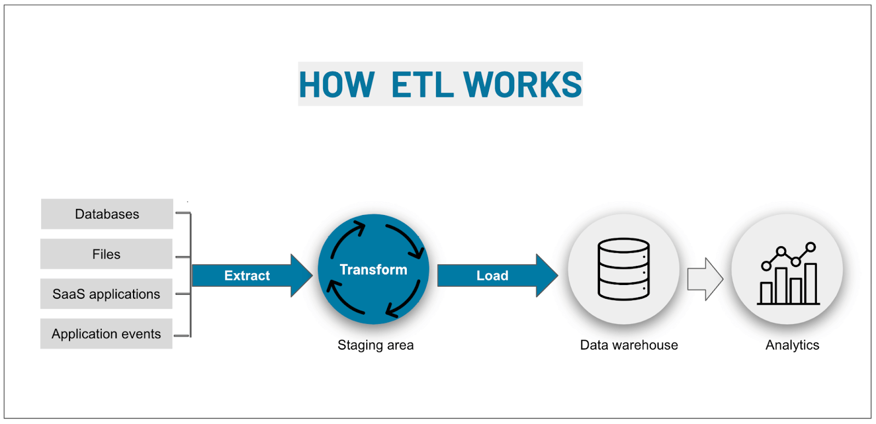

***Challenges Associated with ETL***

*1. Diverse Source Systems:*

*Variability in platforms, operating systems, and legacy databases.*

*2. Historical Data:*

*Lack of historical change tracking in source systems.*

*Historical data is essential for meaningful insights in data warehouses.*

*3. Data Quality Issues:*

*Inconsistent data formats across systems (e.g., monthly vs. weekly salary).*

*Ambiguous codes (e.g., R = Regular, D = Deceased).*

*4. Changing Source Structures:*

*Business needs cause frequent updates in source systems.*

*5. High Project Effort:*

*ETL processes often consume 50–70% of project resources.*

***Load, Append, Destructive Merge, and Constructive Merge***

*Load*

*Definition:*

*Overwrites existing data in the target table with new incoming data.*

*Application:*

*Used for initial loading or complete refresh of the data warehouse.*

*Diagram:*

*Table starts empty → Incoming file data populates the table.*

*Append*

*Definition:*

*Adds new data while preserving existing records in the target table.*

*Handling Duplicates:*

*Define whether duplicates are allowed or rejected.*

*Diagram:*

*Table has existing records → New records are added to the table.*

*Destructive Merge*

*Definition:*

*Updates existing records when a match is found based on primary keys.*

*Adds new records if no match exists.*

*Application:*

*Keeps data uptodate by replacing outdated entries.*

*Diagram:*

*Table records are updated where matches exist, and new entries are added.*

*Constructive Merge*

*Definition:*

*Adds new records even if a match is found.*

*Marks new records as superseding old ones without overwriting.*

*Application:*

*Maintains historical data while tracking the latest changes.*

*Diagram:*

*Table contains old and new records, with new records marked as current.*

*whhat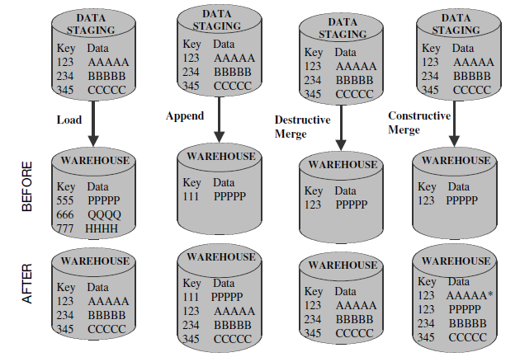*

*1. Load*

*Definition:*

*In the Load operation, the entire content of the target (warehouse) is wiped clean, and the new data from the staging area is fully replaced.*

*Implementation:*

*Before Load: The warehouse contains outdated data (`555 PPPPP`, `666 QQQQ`, `777 HHHH`).*

*After Load: All old data is removed, and new records (`123 AAAAA`, `234 BBBBB`, `345 CCCCC`) from the staging area are loaded into the warehouse.*

*2. Append*

*Definition:*

*In the Append operation, new records from the staging area are added to the existing records in the warehouse, without overwriting or modifying any existing data.*

*Implementation:*

*Before Append: The warehouse already contains `111 PPPPP`.*

*After Append: The records from the staging area (`123 AAAAA`, `234 BBBBB`, `345 CCCCC`) are added without altering the existing data (`111 PPPPP`).*

*3. Destructive Merge*

*Definition:*

*In a Destructive Merge, existing records in the warehouse are updated when a match (based on primary keys) is found in the staging area. If no match exists, new records are added. This ensures the warehouse always contains the most uptodate data but replaces outdated data.*

*Implementation:*

*Before Destructive Merge: The warehouse contains outdated data (`123 PPPPP`).*

*After Destructive Merge:*

*The record with key `123` is updated from `PPPPP` to `AAAAA` (new data from staging).*

*New records (`234 BBBBB`, `345 CCCCC`) from the staging area are added.*

*4. Constructive Merge*

*Definition:*

*In a Constructive Merge, existing records are not replaced, even if there is a match in the staging area. Instead, a new version of the record is created while keeping the old one intact. The newer record may be marked as the current or active version.*

*Implementation:*

*Before Constructive Merge: The warehouse contains `123 PPPPP`.*

*After Constructive Merge:*

*The original record `123 PPPPP` remains intact.*

*A new record for `123 AAAAA` is added, and it may be marked as the latest version (e.g., using a marker like `` for `123 AAAAA`).*

